Consolidated Mosquito Abatement District

Adult Mosquito Control Office Program Workflow

Regulatory Background
Under Title 3 of the California Code of Regulations, Section 6620, vector control operations are exempt from Sections 6616 (Consent to Apply) and 6618 (Notification) if the insecticide is registered for residential use and applied according to the label. The Consolidated Mosquito Abatement District qualifies for this exemption; however, the District prioritizes cooperation with residents who have concerns about insecticide exposure or request pre-treatment notification.

Program Overview
Among all mosquito control operations, ULV (ultra-low volume) adulticide applications pose the greatest risk of exposure to people and pets. This aspect of our program often causes the most stress for residents, potentially leading to complaints or confrontational behavior during treatment. Early notification is critical to reducing exposure risks, minimizing adverse reactions, and avoiding investigations. Therefore, executing the following process takes top priority once a positive mosquito pool is confirmed.
If you or your staff are assigned any of the steps listed below and cannot begin immediately or follow through upon receipt of positive pool results, please notify Jodi, who is capable of completing the entire process to avoid any delay.

Program Workflow:
Step 1: Map Positive Pools
- Verify data for accuracy. Entry errors occur—check comments for address discrepancies and confirm alignment with TRS.
- Export mosquito pool data from CalSurv/VectorSurv.
Step 2: Generate Preliminary Treatment Areas and Overview Map
- Use only positive pools for mapping.
- Generate a 0.25-mile polygon buffer around positive sites.
- Submit draft maps to Chris for review (or Jodi if Chris is unavailable).
- Incorporate any map modifications as directed.
Step 3: Finalize Treatment Areas
- Revise treatment polygons per Chris's or Jodi’s feedback.
- Maps should have the treatment date and approximate times.
Step 4: Produce Community Notice Maps
- Use finalized treatment areas to generate community-facing notice maps.
Step 5: Pull Spray Notification List
- Ensure the restricted layout is current.
- Residents can be added to the spray list on any day.
Step 6: Update Website – Spray Map
- Update the “Scheduled Treatment Areas for Adult Mosquitoes” page before Kathy sends notifications. Kathy’s emails and posts contain links to the website.
NOTE – If Kathy receives spray notifications late in the day and is unable to complete them, do not update the website. Posting public-facing treatment information without first notifying residents who have requested early notification undermines our commitment to resident communication. It shows we knew about, planned, and prepared for treatment, but neglected to notify those most concerned about pesticide exposure at the earliest opportunity.

Step 7: Send Notifications
- Email spray notifications and community maps to Kathy.
- Send community maps to Annie as well.
Step 8: Update Website – Disease Monitoring map
- Office staff will direct inquiries to the District’s website for information on disease activity. Since staff also communicate this information directly to the public about treatment and disease activity, it is essential that all public-facing messaging remains consistent and aligned.
Step 9: Ensure ULV devices are ready for Chris’s deployment (Thursday 3pm)
- Priority should be given to making sure a sufficient number of devices are charged and ready for use at the earliest opportunity.
- Secondarily, routing and digitizing of spray routes can be completed as time allows. This should be the final step in the process, as it is the least essential and can be omitted entirely if necessary. Even without implementing spray routes, the devices can still be used effectively and will continue to capture data without issue.
Step 10: The following day, verify all areas were treated. Update the “Scheduled Treatment Areas for Adult Mosquitoes” to show no areas scheduled for treatment.

Step 11: Update the Surveillance dashboard to indicate the areas treated. This aids in decision-making for future pooling.
Step 12: Sync Mesa Device - verify spray records present.

Resident Communication Channels

Website
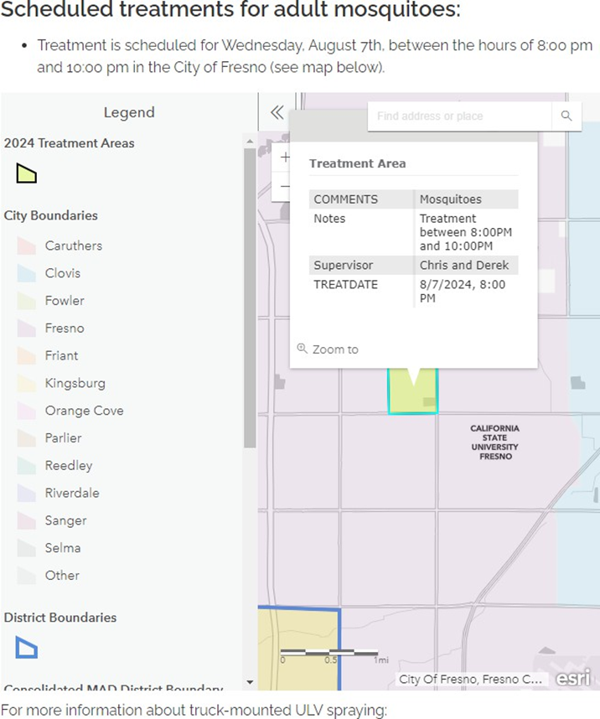
The “Scheduled Treatment Areas for Adult Mosquitoes” page is updated once treatment zones are defined. Residents can search their address using the map’s search tool to determine if they fall within a scheduled spray area. Clicking on a treatment zone provides date, time, and other application details.
- NextDoor (Neighborhood Social Platform)
The District posts in affected neighborhood groups with the following example text:
West Nile virus activity has been detected. Spraying for adult mosquitoes is scheduled for Wednesday, August 7, between 8:00 PM and 10:00 PM.
Protect yourself and loved ones by using an EPA-registered insect repellent (https://www.cdc.gov/mosquitoes/prevention/).
ULV applications of registered insecticides will be made to reduce adult mosquitoes in this area. Weather permitting, treatment will occur Wednesday, August 7, between 8:00 PM and 10:00 PM.
View the treatment area map online: https://www.mosquitobuzz.net/scheduled-treatment-areas-for-adult-mosquitoes. Not all streets will be treated.
You do not need to leave the area. If you prefer, you may stay indoors and close windows and doors during spraying, but it is not necessary. Pets are not harmed by the treatment, though you may bring them indoors if you choose.
More info: https://www.cdc.gov/mosquitoes/mosquito-control/truck-spraying.html.
Check your property for standing water and dump containers. Report unmaintained pools or other sources of standing water to the District.
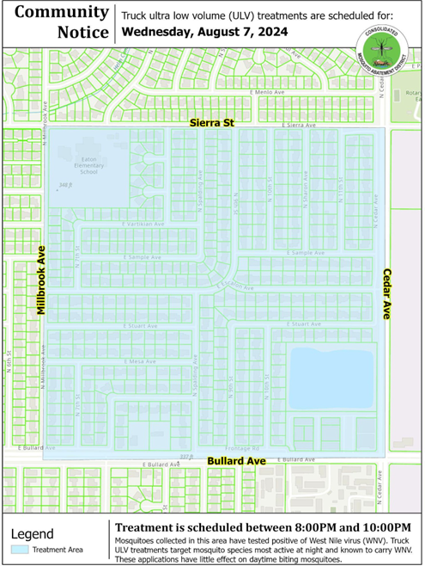
- Direct Spray Notifications
Residents may sign up to receive prior notice of ULV spraying by phone, text, or email via our website or by calling the District. Those on the notification list are contacted before applications occur.
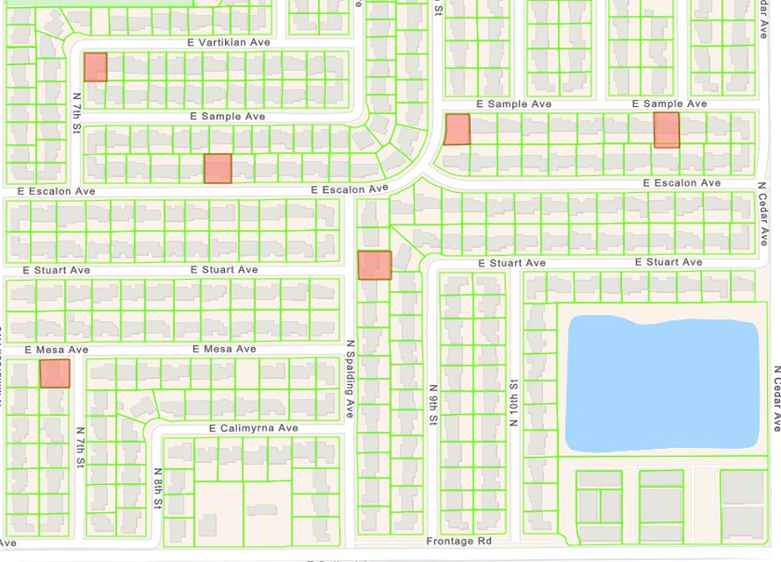
Some residents have opted for a “No Spray” designation. These addresses are flagged on spray maps, and applicators are informed. These residents also receive advance notification.
Important Note: Residents should understand the risk of spray drift. While the District takes precautions to minimize drift, wind conditions can change rapidly. The District cannot guarantee that adjacent or nearby properties will not be exposed.

Public Awareness and Law Enforcement Notification
Despite best efforts, many residents are unfamiliar with special districts, their funding, and available services—including the option to receive spray notifications. Increasing awareness remains a challenge.
In addition to resident notifications, the District provides local law enforcement with community spray maps and applicator contact information. This helps reduce confusion or concern if residents call in reports during ULV applications.

